The Impact of AI-Powered Question Rephrasing on Cognitive Bias in Survey Responses
Matthew Altobelli & Tina Sutton, PhD

Rochester Institute of Technology

Abstract
Cognitive biases in survey research represent a significant threat to data validity. This study investigated the efficacy of an AI-powered tool’s mitigation of three common biases: acquiescence, social desirability, and the availability heuristic. A between-subjects experiment was conducted with 191 college students who were randomly assigned to receive either original, biased survey questions (n = 94) or questions rephrased by an AI to be more neutral (n = 97). The results demonstrate that the AI intervention had a notable effect, producing statistically significant changes in 33% of the targeted questions. The rephrasing was particularly effective at reducing acquiescence bias, with 60% of relevant questions showing a significant effect. The intervention did not produce a statistically significant change in social desirability bias, but it successfully altered responses for questions susceptible to the availability heuristic (p < .01). An analysis of predictive validity found that for study preferences, the unbiased questions showed significantly better alignment with subsequent behavioral choices (p = .020). These findings indicate that AI-powered tools offer a scalable and effective solution for improving survey data quality, filling a critical gap in methodological literature by automating a traditionally manual and resource-intensive process.

Introduction
The validity of survey-based research hinges on the quality of the data collected, which can be compromised by cognitive biases in respondent answers. Biases such as acquiescence (the tendency to agree with statements), social desirability (the tendency to over-report positive behaviors), and the availability heuristic (overweighting recent or vivid information) can distort findings and lead to erroneous conclusions. Traditional methods for mitigating these biases, such as careful manual question wording, the use of balanced scales, and extensive pre-testing, are effective but often resource-intensive and difficult to scale.

The proliferation of artificial intelligence presents a novel opportunity to address this long-standing methodological challenge. While AI has been used for data analysis, its potential to automate and enhance the survey design process itself remains underexplored. This study fills a critical gap in the literature by evaluating the effectiveness of an AI-powered tool designed to automatically rephrase biased survey questions to be more neutral and objective.

This experiment tested the following primary hypotheses:

- H1 (Randomization): The random assignment will result in demographically equivalent groups.
- H2 (Acquiescence Bias): The AI-rephrased questions will produce significantly different response distributions compared to the original, biased questions.
- H3 (Social Desirability Bias): The AI-rephrased questions will lead to more honest self-reporting on sensitive topics.
- H4 (Availability Heuristic Bias): The AI-rephrased questions, which remove priming language, will lead to different response distributions.
- H5 (Predictive Validity): The relationship between survey responses and related behavioral choices will differ between the two groups.

Method

Participants
Participants were 191 undergraduate students from a large university, recruited through a subject pool. The sample consisted of 94 participants in the control group (Group A) and 97 in the treatment group (Group B). The mean age of the sample was 19.4 years (SD = 1.5). The randomization check confirmed the groups were balanced on key demographics including age, gender, and year in college (all p > .05).

Design and Materials
The study employed a between-subjects experimental design. The independent variable was the Question Format, with two levels: Biased (the original survey questions) and AI-Rephrased (questions rewritten by the AI tool). The dependent variables were the participants’ responses to the 15 survey questions and their choices in 5 subsequent behavioral allocation tasks.

The survey instrument consisted of 15 questions designed to elicit the three targeted cognitive biases (5 questions per bias). For example:

- Biased (Acquiescence): "Do you prefer studying in a group?" (Yes/No)
- AI-Rephrased: "What is your preferred way to study?" (Group Study / Studying Alone)

Following the survey, participants completed five behavioral allocation tasks where they distributed a fixed number of points (e.g., 100) across several options related to topics from the survey (e.g., technology preferences, study resource allocation).

Procedure
Participants completed the study online. After providing informed consent, they were randomly assigned to either the control or treatment condition. They completed the 15-item survey and then proceeded to the five behavioral allocation tasks. Upon completion, participants were debriefed and compensated for their time.

Results
Data were analyzed using a series of chi-square tests of independence and independent-samples Mann-Whitney U tests to compare the responses between the two groups. The choice of test was determined by the level of measurement of the dependent variable. Chi-square tests were used for categorical response options, as they are appropriate for comparing frequency distributions between independent groups. Mann-Whitney U tests were used for ordinal data (i.e., GPA), as this non-parametric test is robust to non-normal distributions and compares the central tendency of two independent groups.

Hypothesis 2: Acquiescence Bias
The AI rephrasing was highly effective at mitigating acquiescence bias, with 3 out of 5 questions (60%) showing a statistically significant effect. The most substantial effect was observed for the question regarding study preference (χ²(1, N = 191) = 33.10, p < .001, V = .42). As shown in Figure 1, the biased question format suggested a majority preference for group study (56%), whereas the unbiased format revealed that a large majority (85%) actually preferred to study alone.

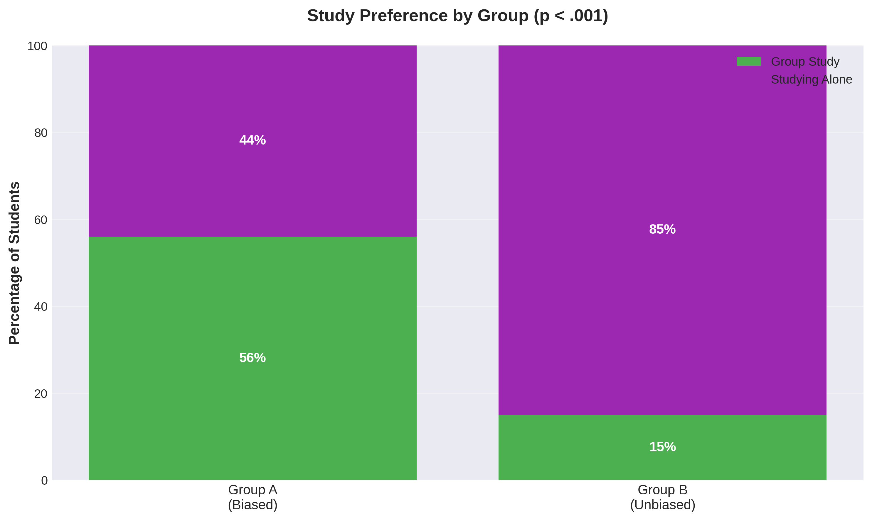
Figure 1: Percentage of students preferring group study versus studying alone by question format condition. Group A received a biased question format, while Group B received an unbiased format

Hypothesis 3: Social Desirability Bias
The analysis does not support the hypothesis that rephrasing can reduce social desirability bias in this context. No significant difference was found in the distribution of self-reported GPA between the two groups (U = 4066.5, p = .174, r = .09). Although the unbiased group reported slightly higher GPAs on average, this difference was not statistically significant. The original question format, therefore, did not appear to suppress honest reporting in a statistically meaningful way compared to the rephrased version.

Hypothesis 4: Availability Heuristic Bias
The tool successfully mitigated availability bias in 2 out of 5 questions (40%). A significant effect was found for the question on coursework stress, χ²(5, N = 191) = 28.43, p < .001, V = .39. The rephrased question, which removed priming language about recent events, resulted in a different distribution of reported stress levels (Figure 2).

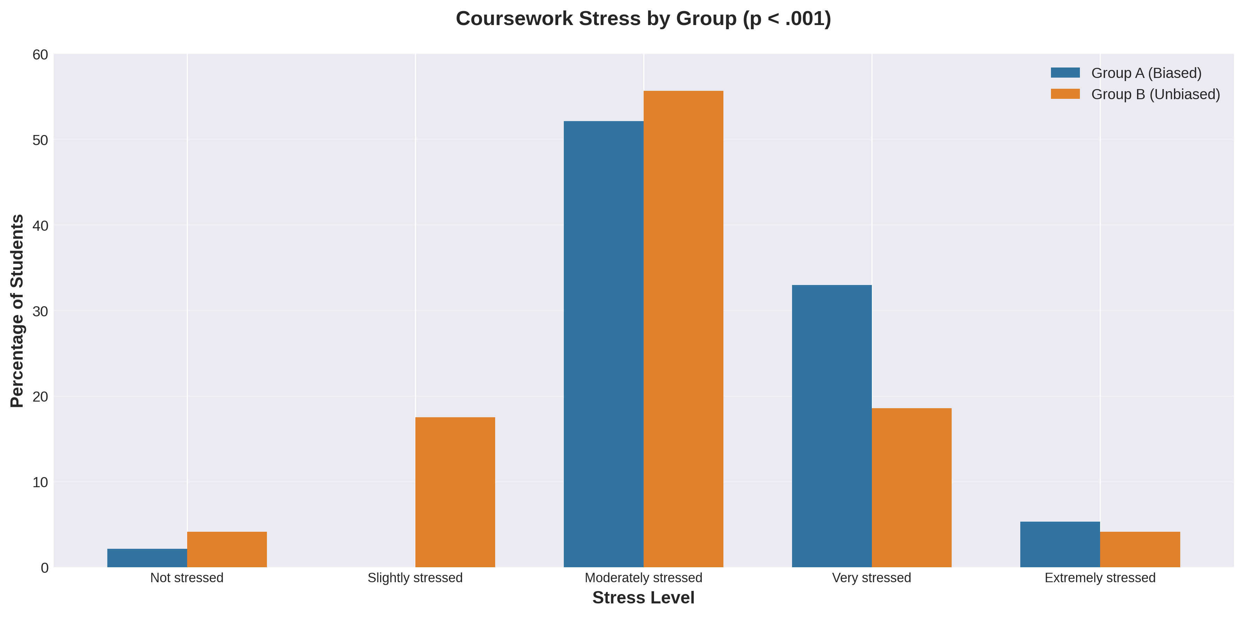
Figure 2. Percentage of students reporting each stress level by question format condition. Group A received a biased question format with priming language, while Group B received an unbiased format

Hypothesis 5: Predictive Validity
The relationship between survey responses and behavioral choices was complex, but the unbiased questions demonstrated superior predictive validity on one key measure. For technology preference, there was no significant difference in alignment between the biased (60.2%) and unbiased (56.7%) groups. However, for study preference, the unbiased questions showed significantly better alignment with behavior (57.3%) compared to the biased questions (39.4%), (χ²(1, N = 190) = 5.42, p = .020). This indicates that for this topic, the clearer, unbiased question was a better predictor of a person’s true behavioral intentions.

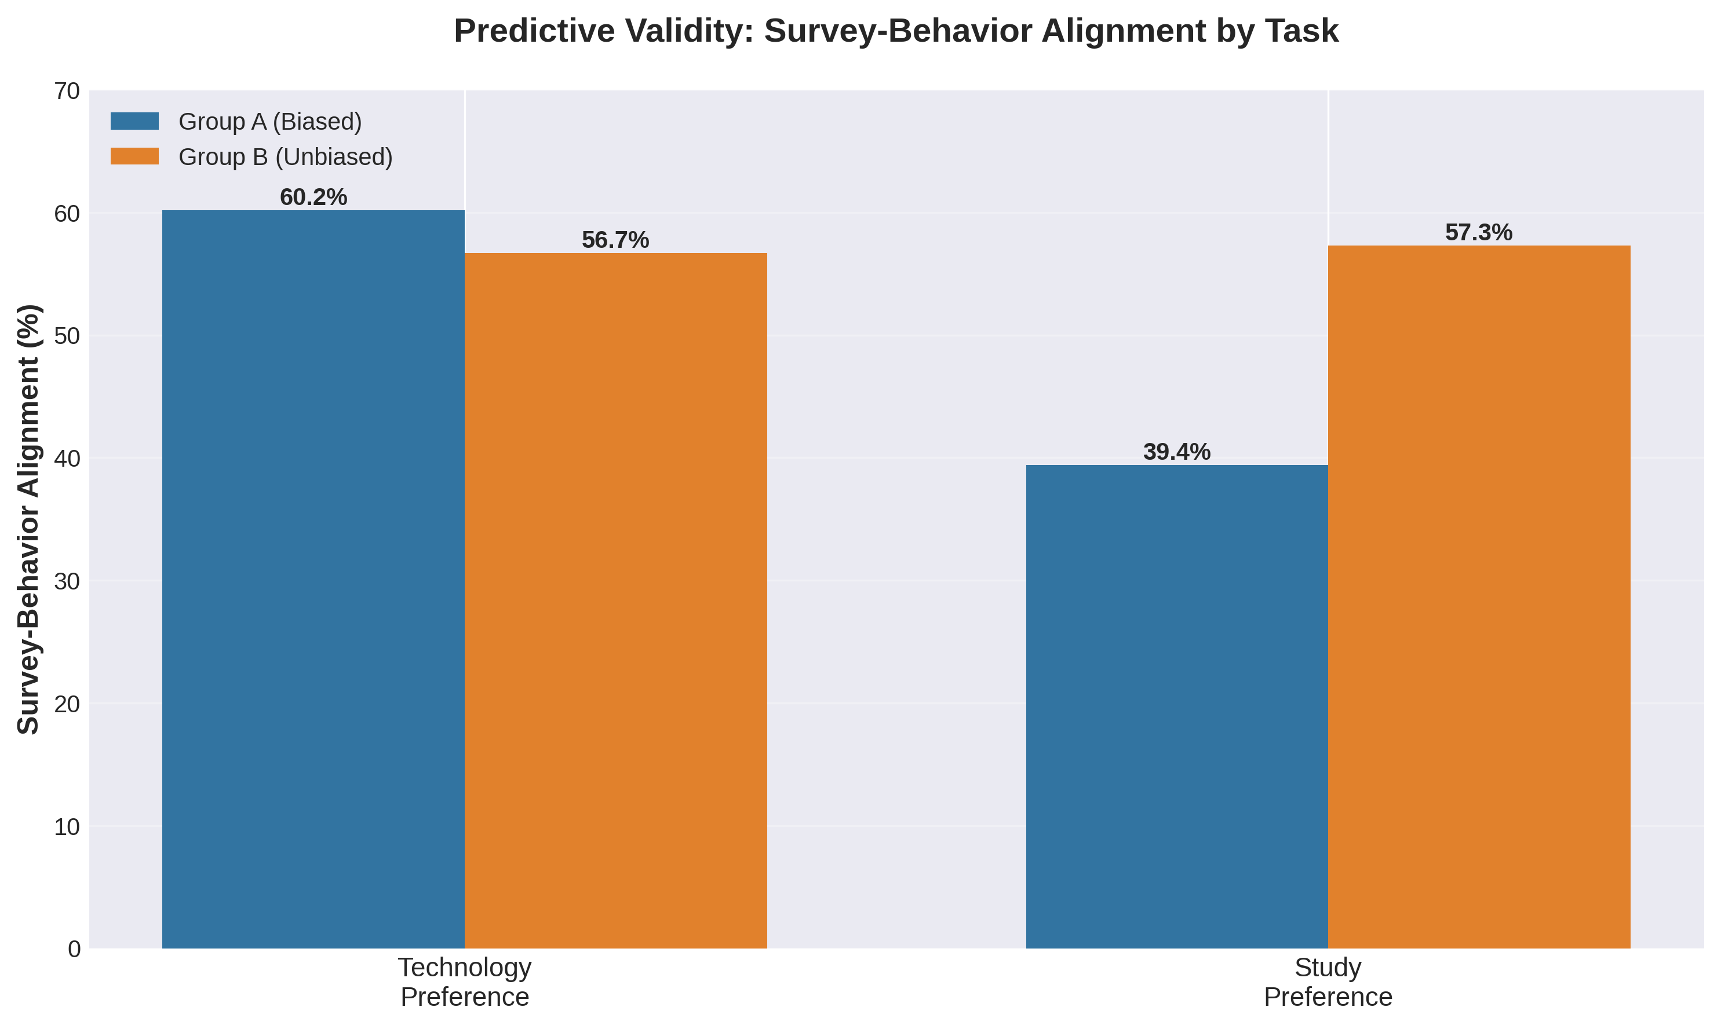
Figure 3. Percentage of participants showing alignment between survey responses and behavioral task choices for technology and study preferences. While technology preference showed no significant difference between groups, study preference revealed significantly higher alignment for Group B (unbiased format, 57.3%) compared to Group A (biased format, 39.4%).

Discussion
The results of this study provide strong evidence that an AI-powered rephrasing tool can be an effective intervention for reducing certain cognitive biases in survey data. The tool demonstrated a notable impact, significantly altering responses in 33% of the targeted questions across all three bias types. This finding suggests that automated tools can successfully perform a task that has traditionally required significant manual effort and expertise, thereby filling a major gap in the methodological literature.

Implications of the Results
The primary implication of this research is that AI can serve as a powerful co-pilot in the survey design process, helping researchers to create more objective and valid instruments at scale. The successful reduction of acquiescence bias, particularly the dramatic reversal in the study preference question, highlights how easily biased formats can lead to fundamentally incorrect conclusions. In contrast, the lack of a significant effect on socially sensitive topics suggests that the tool’s effectiveness against social desirability bias may be topic-dependent or require more substantial alterations to the question framing.

The findings on predictive validity are particularly compelling. For study preference, the unbiased question was a significantly better predictor of behavior. This suggests that for topics where attitudes are well-formed, a clearer, unbiased question is superior for tapping into a person’s true behavioral intentions.

Limitations and Future Directions
This study has several limitations. The sample consisted solely of college students, which may limit the generalizability of the findings to other populations. The study also focused on only three types of cognitive bias; future research should explore the tool’s effectiveness on other biases, such as framing effects or anchoring.

Future research should focus on the mechanism behind the observed effects. While the tool was effective, it is not entirely clear why. Is it the change in wording, the format, or a combination of both? An interesting exploratory finding was that the unbiased group was more likely to choose "TIE/Undecided" on a complex behavioral task. This suggests that while unbiased questions can clarify preferences, they may also increase indecision on topics where attitudes are not strongly held. This avenue of research, the link between bias, attitude clarity, and behavioral decision-making, is a promising direction for future studies.

This study provides a strong proof-of-concept for the use of AI in survey design. By automating the process of bias reduction, such tools have the potential to significantly improve the quality and validity of survey data across the social sciences.

Tables and Figures
Table 1. Summary of Hypothesis Tests

Hypothesis | Question | Test Statistic | P-Value | Result
H2: Acquiescence | GroupVSAlone | χ² = 33.10 | p < .001 | Supported
H2: Acquiescence | ValueofCampusDining | χ² = 15.62 | p < .001 | Supported
H2: Acquiescence | MentalHealthResources | χ² = 8.12 | p = .004 | Supported
H3: Social Desirability | GPA | U = 4066.5 | p = .174 | Not Supported
H4: Availability | Safety | χ² = 13.52 | p = .009 | Supported
H4: Availability | CourseworkStress | χ² = 28.43 | p < .001 | Supported
H5: Predictive Validity | Technology | χ² = 0.12 | p = .731 | Not Supported
H5: Predictive Validity | Study | χ² = 5.42 | p = .020 | Supported
Note: Only significant findings and key predictive validity tests are shown for brevity

